Personal Details – User Interface



* When logged on: Guest replaced with First name and Surname.
* Maybe change the background color of the banner.

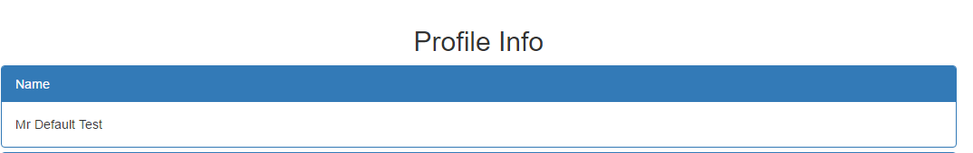

* Show name and surname

Add panel to show:

Email address.

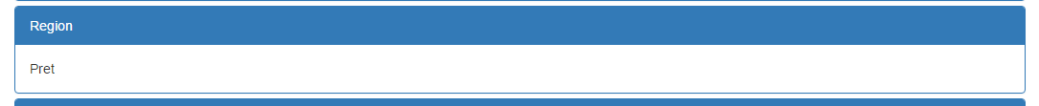

* Change this panel to show the full address.
* Change panel title to Physical Address.

Add panel for Bank details:

* Bank name:
* Bank branch
* Branch number
* Account number

Use some creativity to make the screen presentable.

:☺:))))))))